**Communication Skills – CSR**

|  |  |  |  |
| --- | --- | --- | --- |
| |  | | --- | |  | |  | | Communication Skills (SkillSoft Professional)  WBT ITM_1009131 | |

Learn to listen

Ask appropriate questions

Show empathy

**CUSTOMER NEEDS**

First need to understand what is it expected from you?

EMOTIONAL/PSYCHOLOGOLICAL NEEDS + BUSINESS/TECHNICAL NEEDS

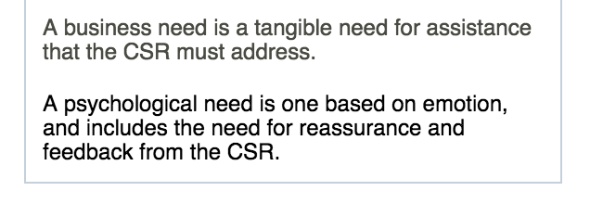

Business need example

Answering an request for information

Helping with a technical problem

Ordering or selling a product/idea or service

Spoken and unspoken messages

* Reassurance and positive feedback
  + Don’t worry this problem can be easily resolved
  + Okay I will do everything I can to help you with this. We’ll soon find a solution to it
  + So you feel let down that your order arrived late and was not complete. Okay lets start at the beginning
* Empathetic and assertive statements
  + I understand how frustration you feel about this situation but let’s see if we can solve this
  + I understand how intimidating this software can seem at first, but I am sure that we can find a solution. I know how frustrating it can be, I myself had difficulties installing it
* Personalized service
  + Refer to the customer by name
  + Okay John I know you are using this for your work so we need to get you back up and running asap
  + I have dealt with similar problems many times before and I’m sure that we can find a solution to your particular problem

**Business Needs**

**Techniques**

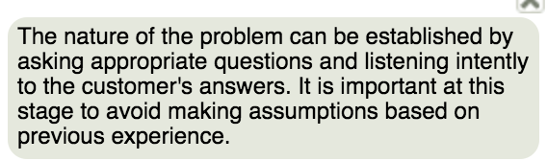

EXAMPLE

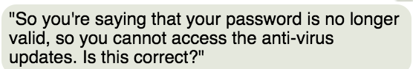

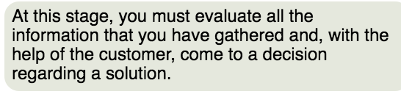

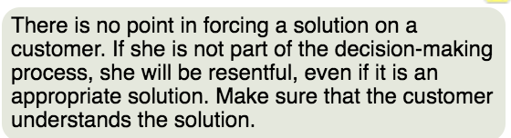

EXAMPLE

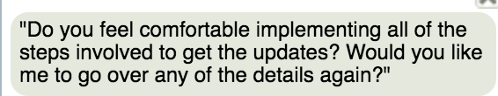

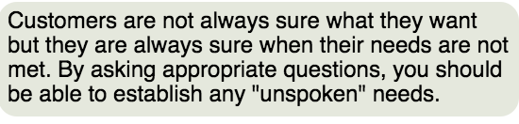

EXAMPLE

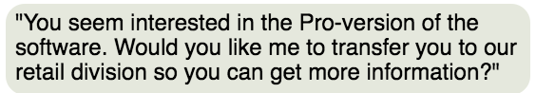

**CALL FLOW PROCESS**

# **The Call-flow Process**

**Purpose:** Use this SkillGuide to review the stages of the call-flow process.

The stages of the call-flow process involve:

1. Greeting the customer: Answer by the third ring, smile, speak clearly, give the customer your undivided attention, identify yourself and your department, offer help, and note the customer's name. Begin the conversation with your customer on a positive note.
2. Listening to the customer: Ignore disruptions, distractions, or uncomfortable surroundings such as noise, lighting, or being too hot or too cold. Concentrate on what the customer is saying to you, and attempt to identify the information that is most important.
3. Determining customer needs: Listen actively to the customer from the beginning of the conversation. Paraphrase what the customer has communicated to you, ask questions, and get feedback.
4. Responding to customer needs: First, provide an empathy statement to address the customer's psychological needs. Then, with the customer, develop an action plan that directly addresses his business needs. Developing an action plan involves informing the customer of the steps you plan to take; explaining any steps he should take; telling the customer the benefits of your actions; indicating the timeframe of the results; and checking to ensure the customer has understood the proposed solutions.
5. Getting agreement: Seek feedback and agreement from the customer at this point to establish whether he is satisfied with the solution.
6. Concluding the call: Smile and have a positive, friendly attitude; use the customer's name; review the plan of action; offer further assistance; and thank him for calling.
7. Following up as necessary: You might want to follow up particularly urgent requests or requests that are critical to a large number of users.

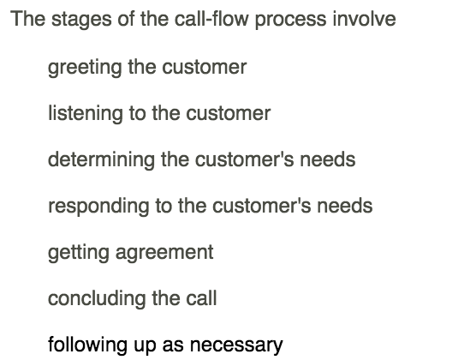

BENEFITS

1. Greeting the customer

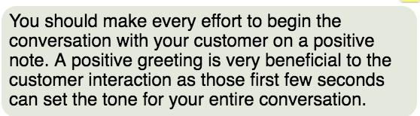

2. Listening to the Customer

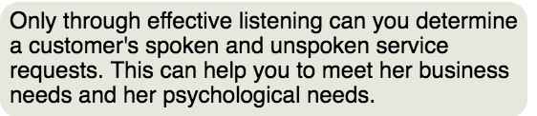

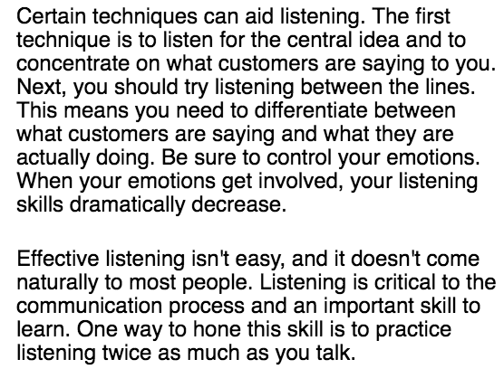

3. Determining the customer’s needs

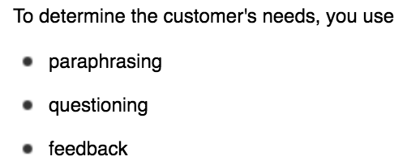

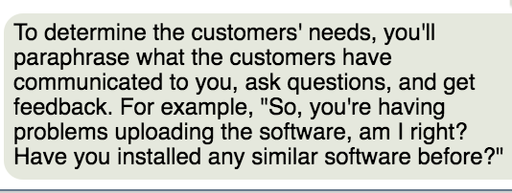

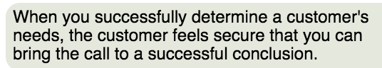

4. Responding to a customer’s needs

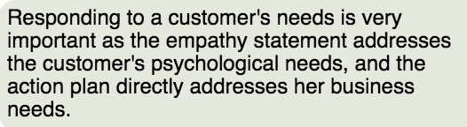

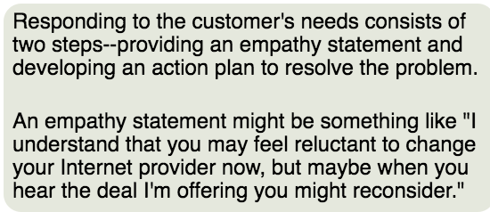

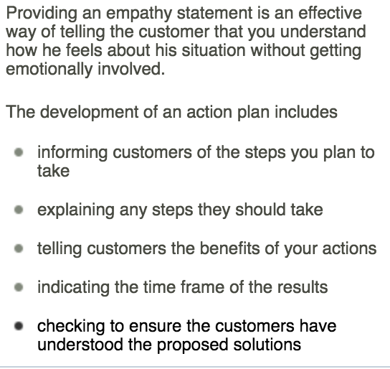

5. Getting agreement from the customer

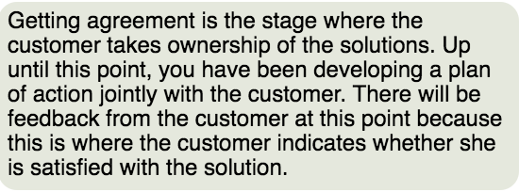

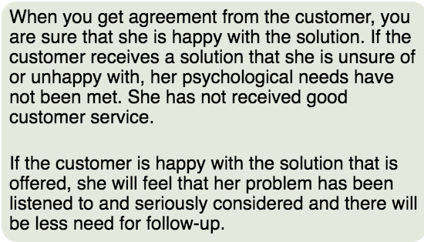

6. Concluding the call

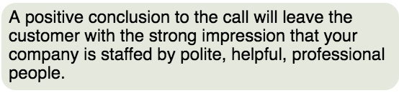

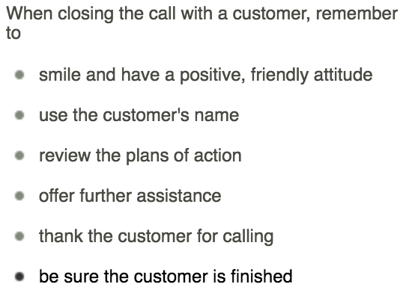

7. Following up with the customer

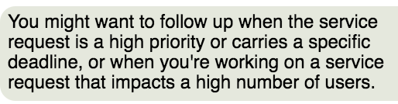

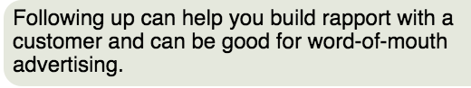

-=-=-=-=-=

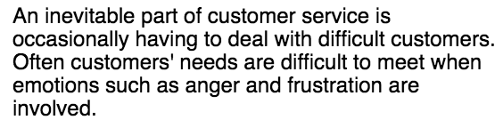

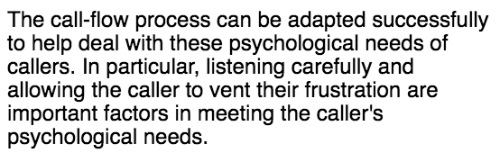

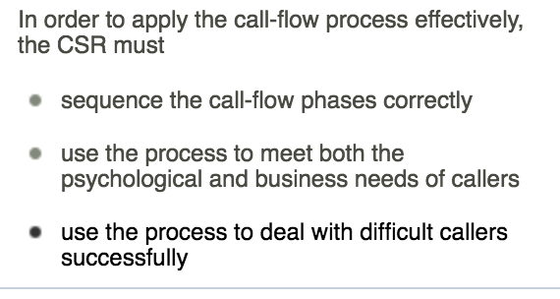

**COMMUNICATION BEHAVIOR TYPES and STYLES**

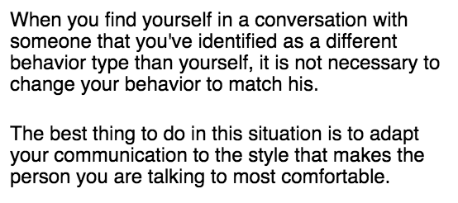

4 common behavior types

1. DIRECT

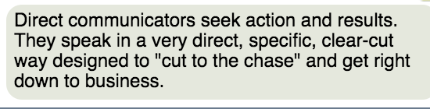

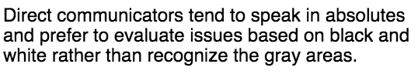

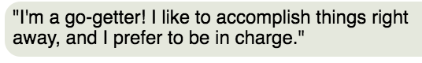

+

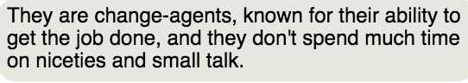

-

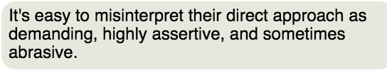

1. ANALYTIC

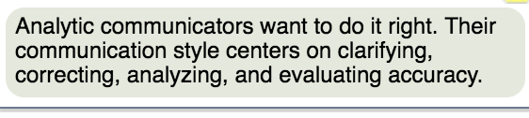

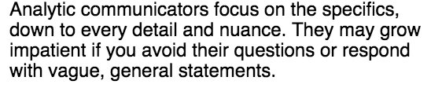

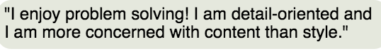

+

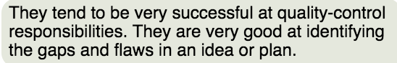

-

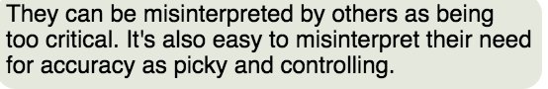

1. COLLABORATOR

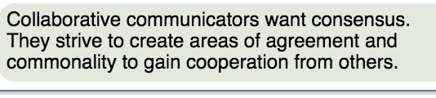

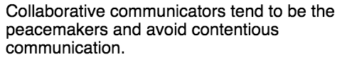



+

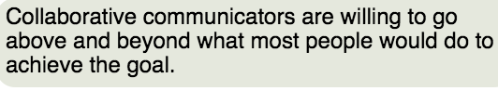

-

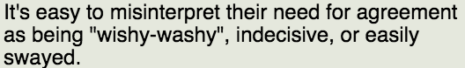

1. INFLUENCER

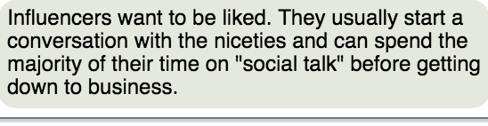

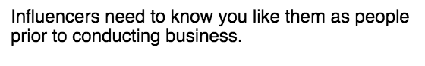

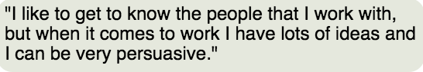

+



-

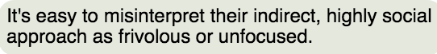

-=-==--=-=-=



TECHNIQUES

DIRECT

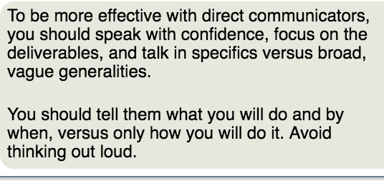

ANALYTIC

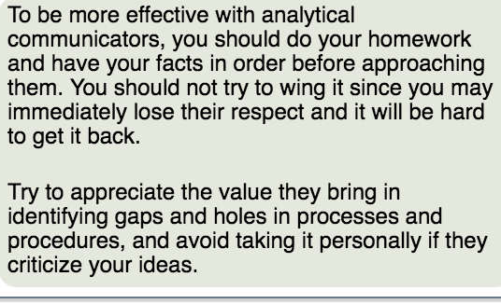

COLLABORATOR

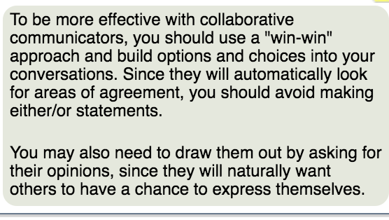

INFLUENCER

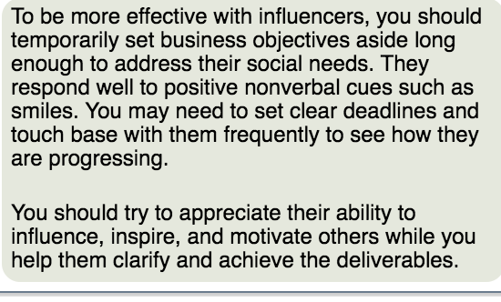

-=-=-=-=-=-=-==-

**COMMUNICATION STYLES**

TECHNIQUES

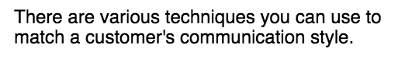

1. Understanding the customer’s level of proficiency

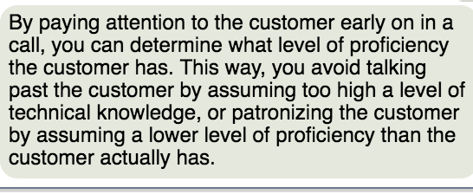

1. Matching the customer’s vocal elements, when appropriate

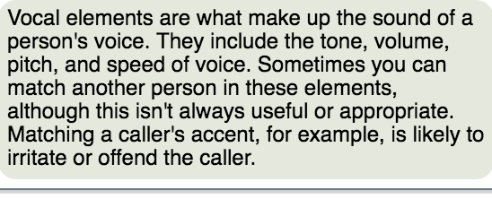

1. Matching the customer’s vocabulary

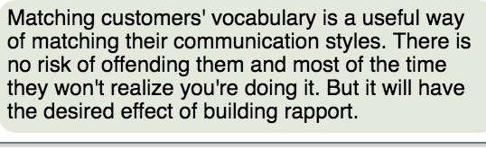

1. Using the same level of technical terminology as the customer

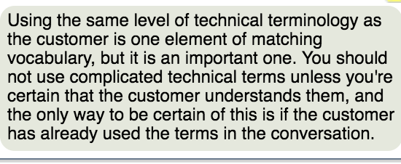

-=-=-=-=-=-=-=-=

**WRITING SKILLS**

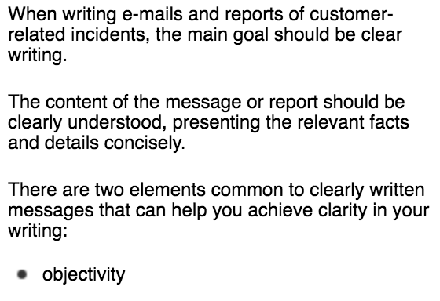

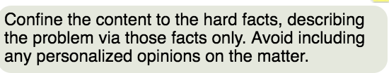



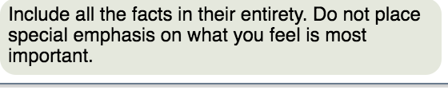

NEGATIVE SCENARIO

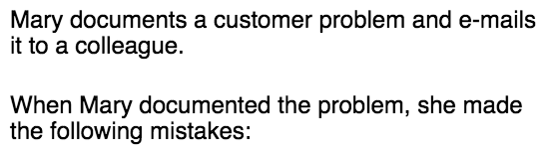

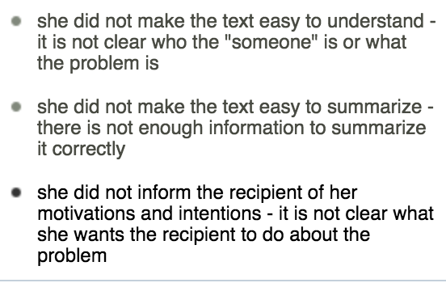

**CUSTOMER SITUATIONS FOR DOCMENTATION**

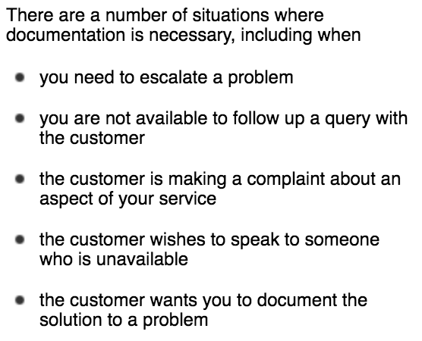

-=-=-=-=-=

DOCUMENT in 4 CATEGORIES

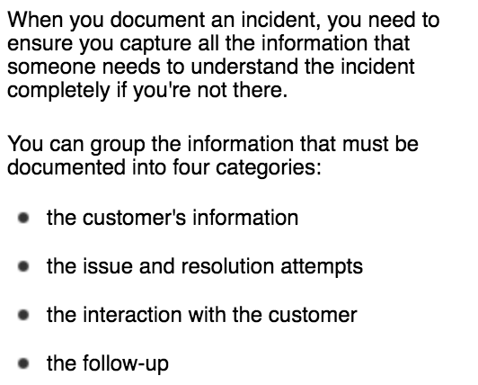

Issue and resolution attempts

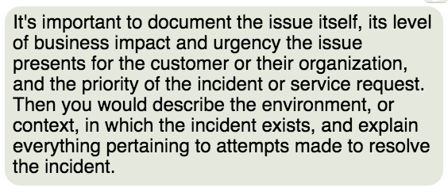

Interaction with the customer (attitude and interactions)

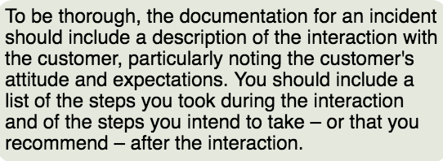

The followup

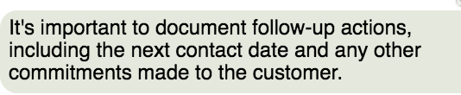

-=-=-=--==-

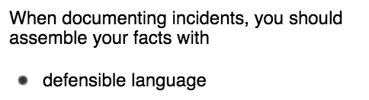

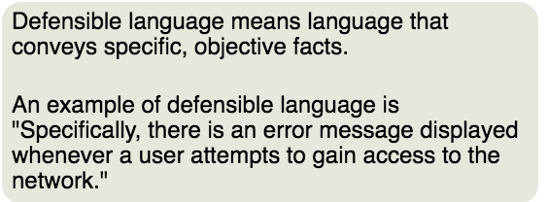

examples









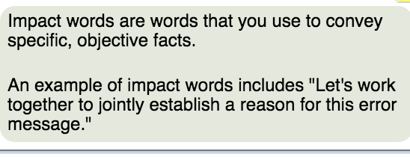

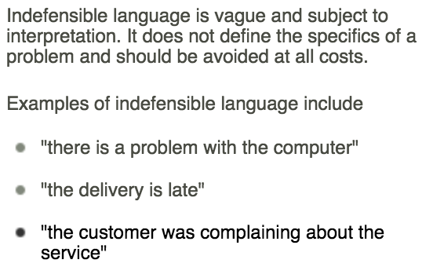

**Customer information**

* The customer's information, including name, department, company, or organization
* The contact name, if different from the customer's name
* Contact information, such as the customer's phone number and e-mail address

**Issue and resolution attempts**

* The business impact and urgency of the issue
* The priority of the incident or service request
* The environment in which the incident exists
* All information pertaining to attempted resolutions

**Details of interaction with customer**

* Details of the interaction with the customer that relate to the incident or service request
* The steps taken during contact with the customer
* The steps that will be taken after contact with the customer

**Follow-up**

* The next contact date
* The commitments made to the customer

--=-=-=-==-

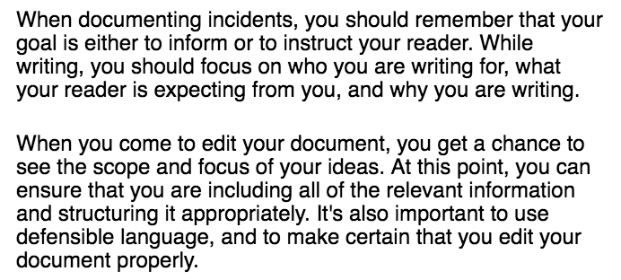

=--=-=-=-=-=-=-=-=-=-=-=-=-=-==-

**EMAIL ETIQUETTE**

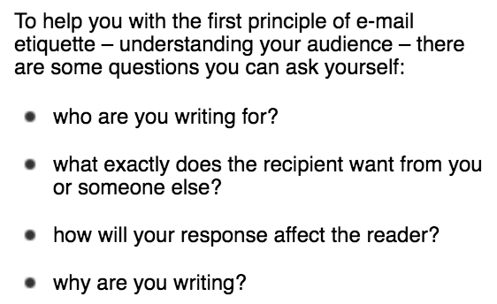

Whoare you writing for

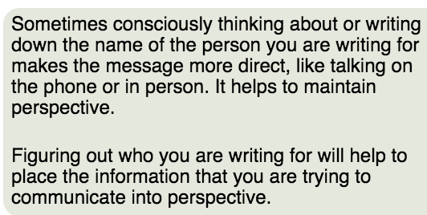

What exactly does the recipient want from you

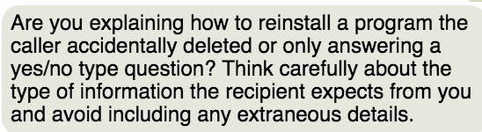

How will your response affect the reader

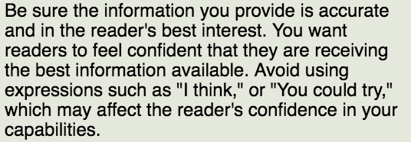

Why are you writing

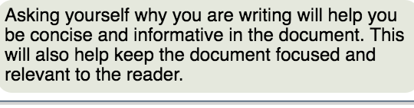

-=-=-=-=-=-=-=-=-=-=-==-

**STRUCTURE OF THE EMAIL – TECHNIQUE**

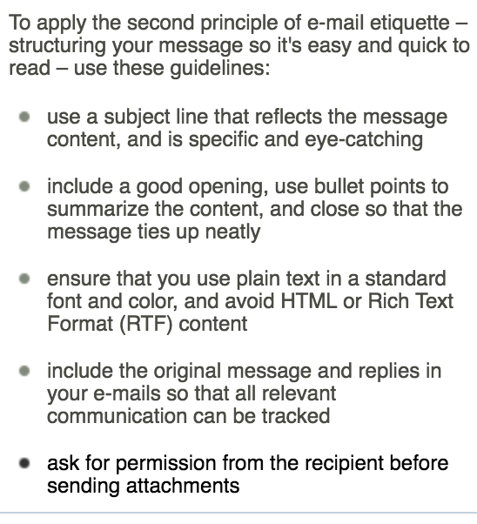

# **Assessing Etiquette in E-mails**

Use this follow-on activity to asses the etiquette in e-mails

**Instructions for use:** Print several e-mail threads between you and your coworkers, or between you and customers, to examine the etiquette in your e-mails.

#### Step 1

Examine two or three e-mail threads containing at least one outgoing and one incoming message between you and your coworkers, or between you and customers. You might find it useful to print out the e-mail threads.

#### Step 2

Rate each e-mail in terms of the following criteria:

* Is the subject line specific to the content, and eye-catching?
* Is the proper case used throughout?
* Are the messages worthwhile?
* Are the preceding messages included in each progressive step?

#### Step 3

Identify areas in which you can improve your e-mail etiquette, and apply what you have learned to future e-mails.

-=-=-=-=-==--=

**COMMUNICATION STRATEGIES**

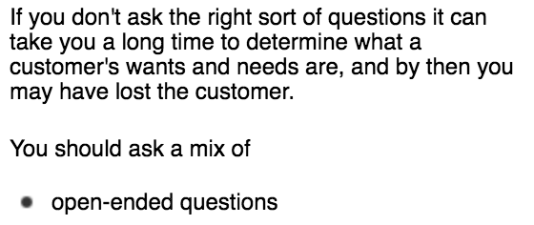

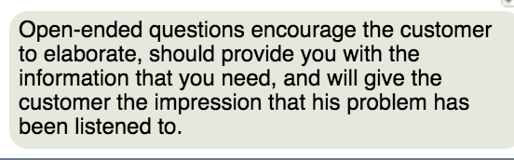



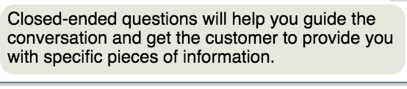

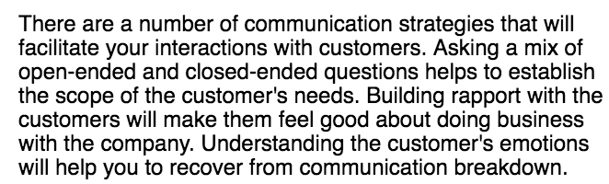

-=-=-=-=-=-=-=-=-=-=-=-=-=

Open Ended Questions

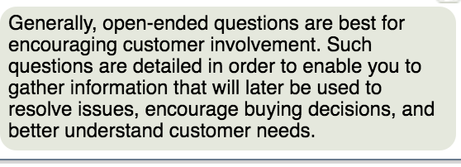

Close ended questions

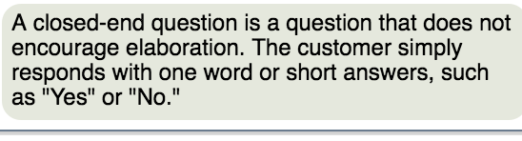

Examples

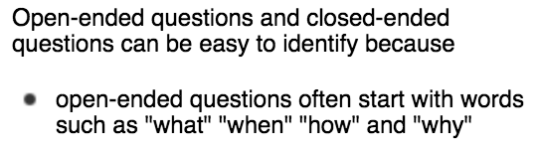

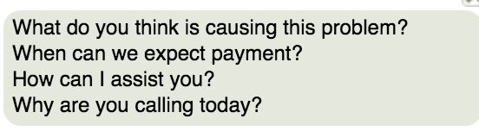

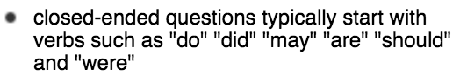

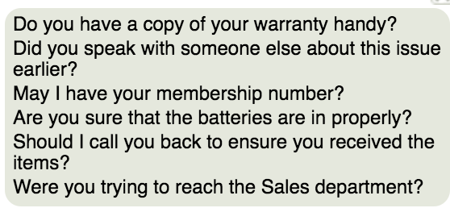

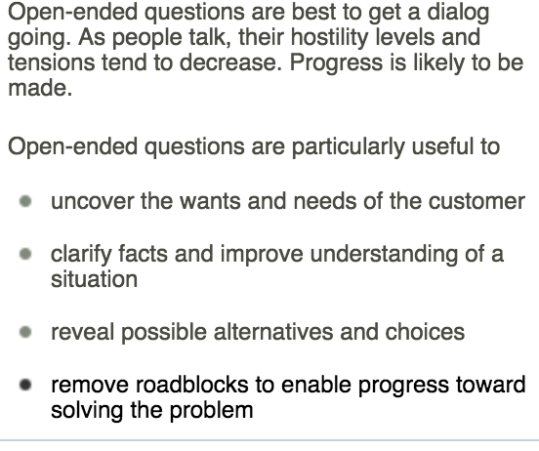

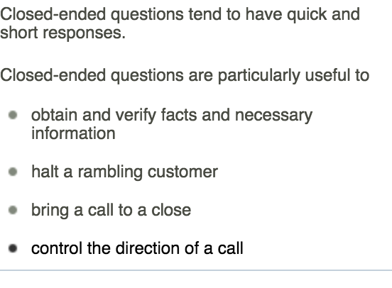

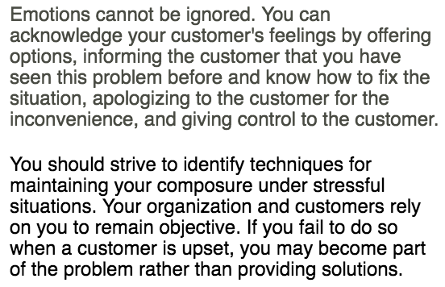

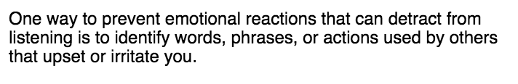

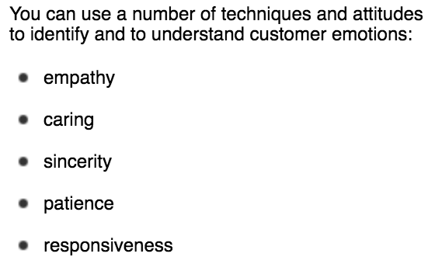

Emapthy

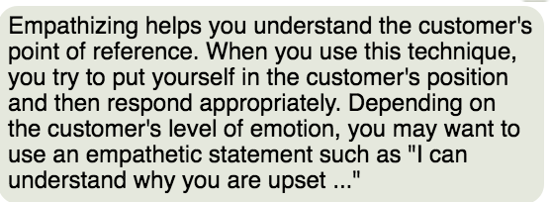

Caring

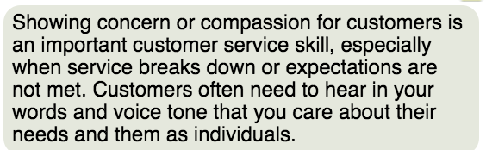

Sincere

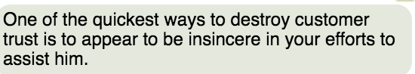

Patience

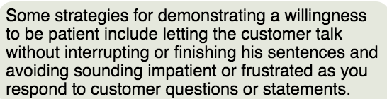

Responsiveness

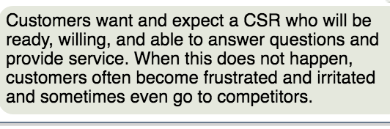

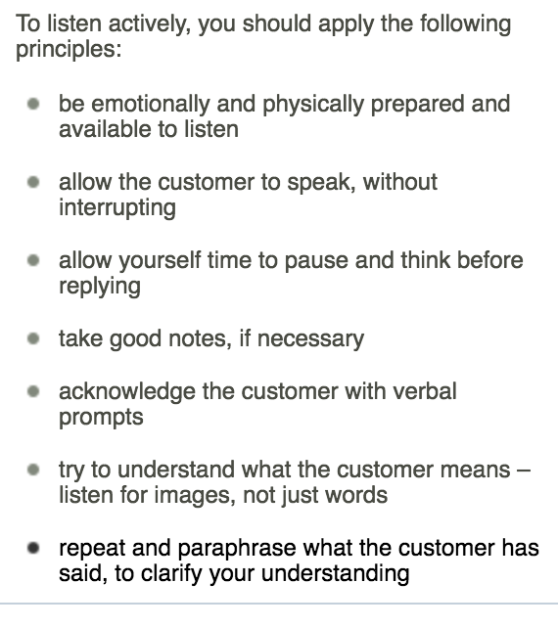

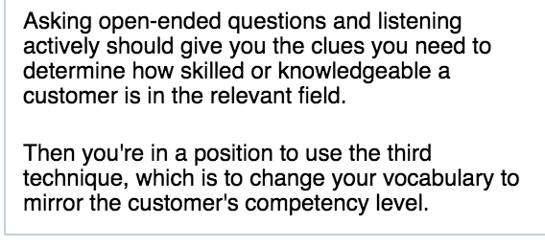

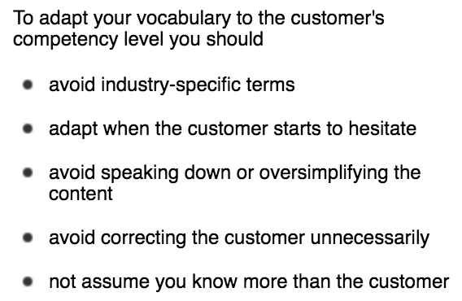

# **Guidelines to Adapt to a Customer's Competency Level**

**Purpose:** Use this job aid to review the guidelines and advice on how to adapt to a customer's competency level.

By applying these guidelines, you will more easily identify the customer's competency level:

**Step 1** – Ask open-ended questions to

* get a clearer understanding of the situation
* discover the customer's requirements and expectations
* begin to investigate alternative approaches to the issue
* free up the communication and focus on the solution
* begin to judge how competent the customer is

**Step 2** – Listen actively to responses

* Be emotionally and physically prepared and available to listen
* Allow the customer to speak, without interrupting her
* Allow yourself time to pause and think before replying
* Take good notes if necessary
* Acknowledge the customer with verbal prompts
* Try to understand what the customer means – listen for images, not just words
* Repeat and paraphrase the customer to clarify your understanding

**Step 3** – Mirror your vocabulary to the customer's competency level

* Avoid industry-specific terms
* Adapt when the customer starts to hesitate
* Avoid speaking down, or "dumbing down" the content
* Avoid correcting the customer unnecessarily
* Don't assume you always know more than the customer

-=-=-=-=-==-=-=--==--==-=-=-=--=-=-=-

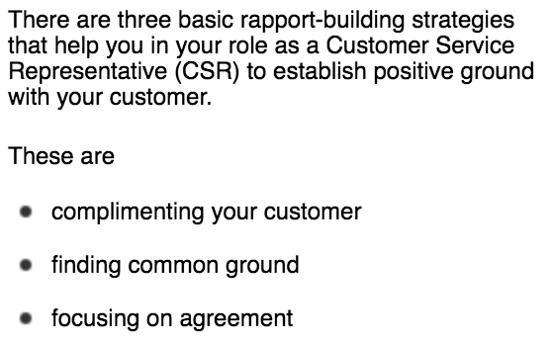

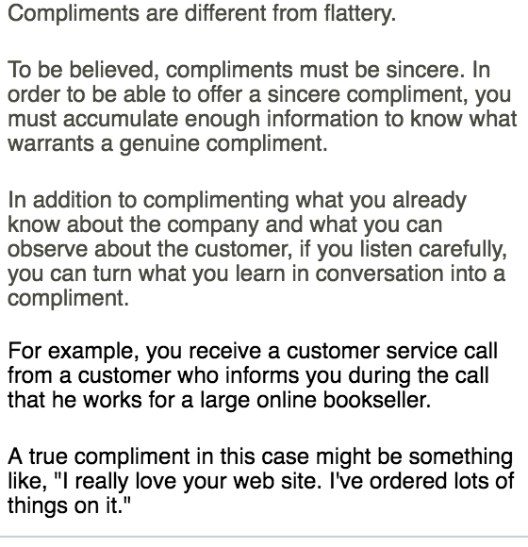

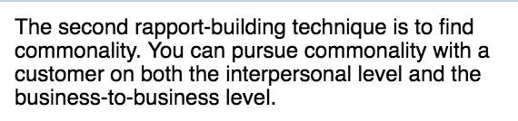

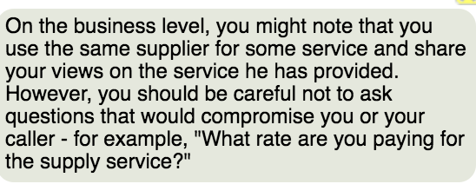

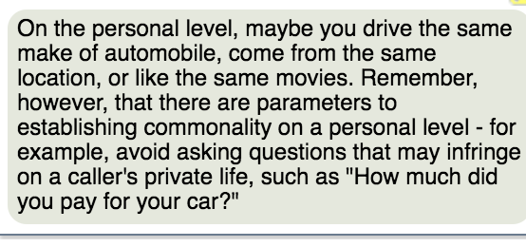

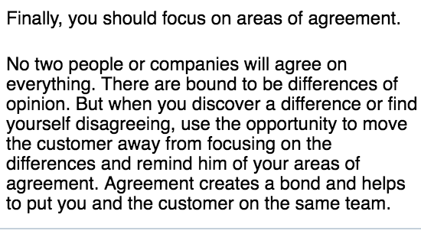

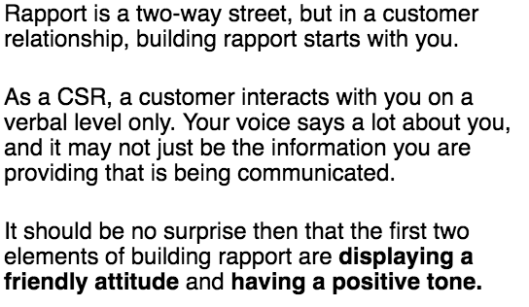

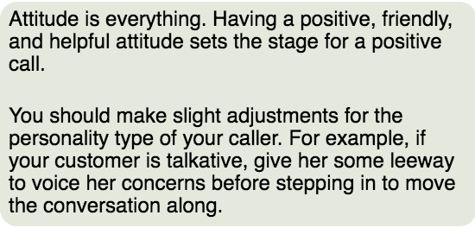

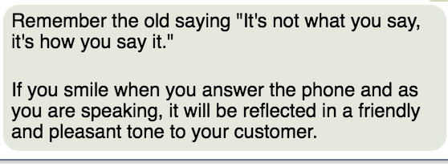

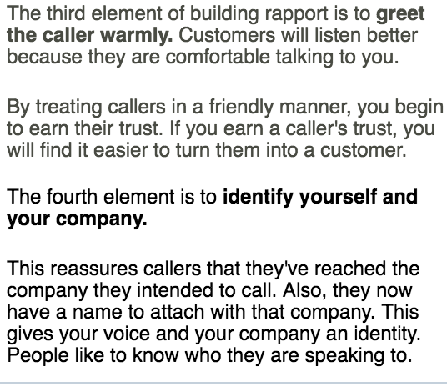

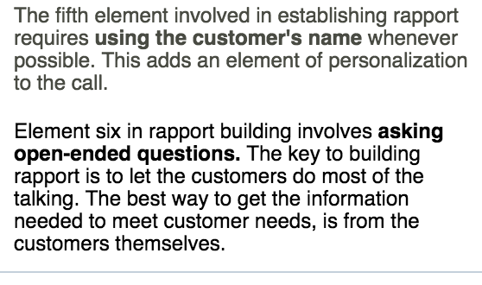

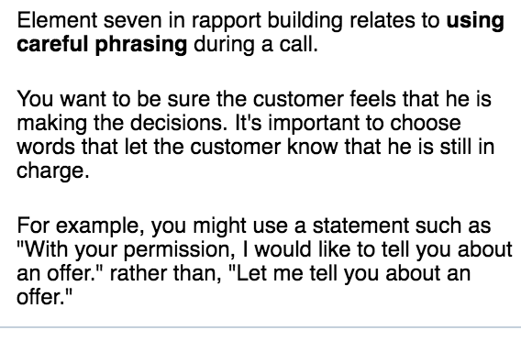

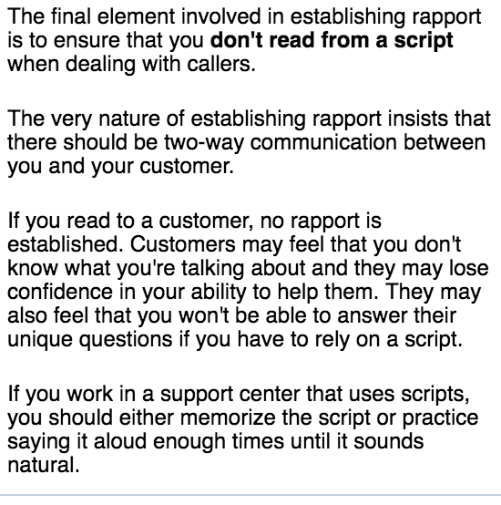

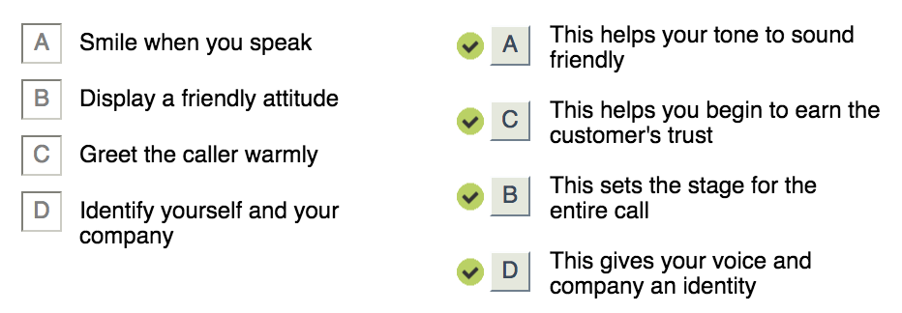

# **Assessing Usage of Techniques for Building Rapport with Customers**

Use this follow-on activity to assess Customer Service Representative's techniques for building rapport with customers.

You will need to have access to a conversation between a Customer Service Representative (CSR) and a customer.

Most customer support centers record conversations between CSRs and customers for quality assessment and training purposes. Check if yours does, and request a copy from your manager. This is the preferred source for this activity because it will enable you to listen and relisten to the conversation. Alternatively, see if you can listen in on a CSR's call. Remember, the customer must be informed if you are going to record the conversation.

Once you have secured access to a conversation – either pre-recorded or live – between a CSR and a customer, listen to the conversation carefully, taking notes of how the conversation develops. Pay special attention to the techniques used by the CSR to build up a friendly, professional rapport with the customer. These include

1. greeting the caller appropriately
2. identifying yourself
3. displaying a friendly attitude
4. having a positive tone
5. using the caller's name
6. asking open-ended and closed-ended questions at appropriate times
7. using careful phrasing
8. refraining from reading to callers